How to run the isofmap_post_requests_UPI.py
1) Setup
- Install Python 3.9+.
- Open a terminal in the folder where the script is located.
- Install required packages:
pip install requests beautifulsoup4
- The UPI Addresses should be in the form of <UPI number, Neighborhood number>
upi_list = [ "VIII 1763",
"XVIII 5678, 2",
"XVIII 5780 2",
"XVIII 5558, 2"]

2) Open and prepare the network tab to get the authorization details
- Open http://www.isofmap.bg/
- Press F12 (or Ctrl+Shift+I) to open DevTools.
- Go to the Network tab.
- In the website search for an UPI in the search box.
- Enable Preserve log.
- In the Network tab you will see a search request you should open.
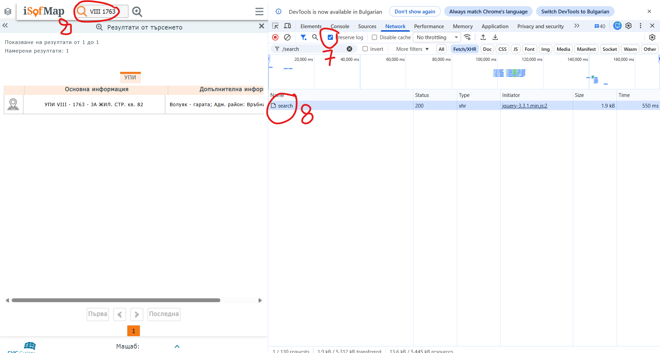

3) Trigger the correct request (POST /search)
- After you open the search request, you need to open the Payload tab
- Find the field named token.
- Copy its value and paste it into the script where token = "...".
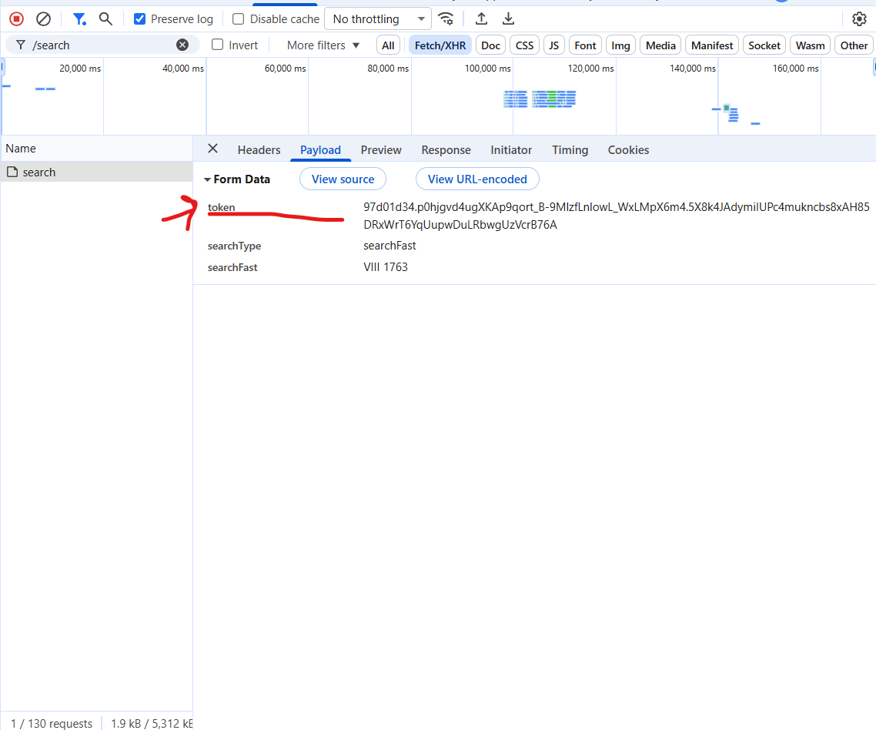

5) Copy PHPSESSID from request headers (Cookie)
- Still on the same POST /search request, open the Headers tab.
- In Request Headers, find the cookie.
- Inside Cookie, locate PHPSESSID=...., _ga=… and _ga_JYN8Q1VR0D=….
- Copy the values of the 3 of them and paste it into the script cookies dicitionary.
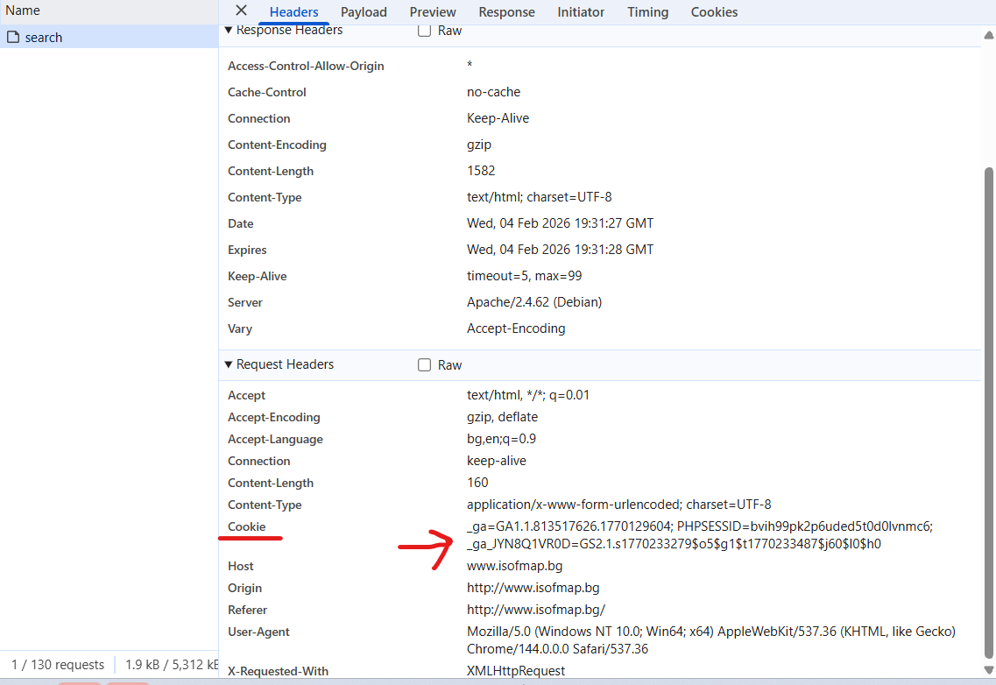
6) Run the script
- Edit isofmap_post_requests_UPI.py: set token and cookies['PHPSESSID'] to the values you captured.
- Optionally update upi_list with the UPI values you want to query.
- Run:
python3 isofmap_post_requests_UPI.py

